Walking the Path of Wisdom & Awakening
Insight/Vipassana Meditation Retreat
Friday 12th March – Thursday 18th March 2021
with Ellen Davison
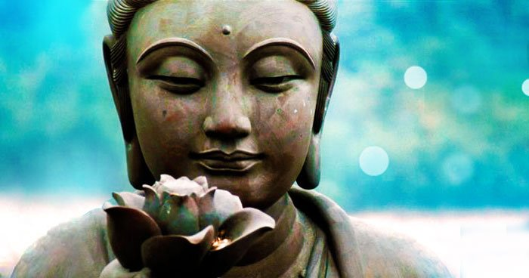
Thank you for your inquiry and interest in this Insight meditation retreat.

This retreat offers an ideal opportunity for established meditators to deepen their practice. Those new to meditation can experience a valuable but gentle introduction to silent meditation and the Dharma teachings in a welcoming, supportive environment.

This retreat program consists of meditation instruction, plus sitting, walking and guided meditations. Individual and group interviews with the teachers, evening Dharma talks and optional yoga/exercise periods are also included. Three delicious vegetarian meals are provided each day.

Sangsurya, www.sangsurya.com.au is a beautiful retreat, meditation and yoga centre on the outskirts of Byron, overlooking Tallow Beach and the Pacific Ocean.

For further retreat information email: vjwight(at)gmail.com (replace (at) with @)

Bookings:

Complete the attached Registration Form and return by email to: vjwight(at)gmail.com. Your full payment or deposit of $170 will need to be received before your registration can be confirmed. Please see below for payment options. After receipt of your registration and payment your booking will be confirmed. Further information eg. travel directions, what to bring etc will be forwarded to you closer to the retreat.

Should the course be full you will be notified and your name will be placed on a waiting list. You will be contacted if a place becomes available. Early registration and payment is strongly encouraged, as places are limited.

Cancellation Policy:
If you need to cancel your retreat registration, please contact us as soon as possible. Cancellation fees are:
- $50 if you cancel four or more weeks before the retreat begins;
- $100 if you cancel less than three weeks before the retreat begins;
- $150 if you cancel less than one week before the retreat.

Etiquette on Retreat:

The majority of the retreat will be conducted in silence. Participants are requested to observe the Five Precepts and to take up the practices of:

- Cultivating kindness and refraining from harmful actions.
- Cultivating appreciation and generosity with possessions and refraining from taking what is not offered.
- Cultivating inner joy and contentment and refraining from sexual expression.
- Cultivating truthful and appropriate communication and refraining from speech that distorts or is damaging.
- Cultivating clarity and refraining habits that create dullness or heedlessness.

Dana:

Following tradition and in recognition of the priceless nature of the spiritual teachings, teachers receive no payments but offer their teachings as a gift. Teachers take time out of their busy lives to conduct retreats and in recognition of their generosity there will be an opportunity for participants to make a donation of support and appreciation to the teacher (dana).

Retreat Fees:

Due to Covid restrictions, couples, housemates or close friends can share accommodation ($705 pp). There are a few private rooms for $765 pp. There are also a few individual camping sites ($465). Please pay $170 deposit or the full amount at time of registering. Note: Full payment is required two weeks before the retreat.

Payment Methods:
Please Note: If you have made a direct debit payment to KYMC for a retreat in the past, this is a new account number.

- Direct deposit/bank transfer to:
BSB: 637-000
Account Name: Kuan Yin Meditation Centre – Retreat Account
Account Number: 719873219
Reference: ‘your surname plus Ell’

Please tick the box if you would like to receive notification of future Insight Retreats
Walking the Path of Wisdom & Awakening
12th March – 18th March 2021

Section 1:
Personal Details:

Name: |  | Gender:
Address:
Email:
Phone: | Mobile: | Home:

Contacts in case of emergency during the retreat:

Name:
Relationship:
Phone contact:

Special Requirements:

Dietary:
Other needs:

Do you have sleep issues that may disturb others?

Transport:

Vehicle registration number:
Can you offer a lift? | One way/ return: | No. of people: | From:
Would you like a lift? | One way/ return: | No. of people: | From:

Note: Reasonable attempts will be made to meet special requirements & lift requests

Section 2:

Participant confidential information
- By completing this section you are providing background information for teachers only.

Name: |  | Gender: | Age:

Life situation and/or occupation:

Current Meditation Practice (if any):

Previous courses with teacher(s) in the Insight tradition

Previous Retreats / meditation practice:

Tradition | Teacher | Year | Length

Current Issues that may make meditation difficult for you at this time:

Physical
Mental / Emotional
Spiritual

Many meditators are on a healing journey. On meditation retreats individuals may experience strong physical and psychological states. Please answer all the following questions so we can care for you appropriately.

Do you have any current or previous:

Drug (including alcohol) abuse or addiction issues | Yes/No | Past | Current
Diagnosis or treatment of a mental illness (psychological or psychiatric) | Yes/No | Past | Current
Medical conditions that could require attention during the retreat, or would affect your participation on the retreat. | Yes/No | Past | Current

If you answered “Yes” above please give further information about your conditions:

Are your symptoms currently well controlled? | Yes/ No
Do you currently drink alcohol on a regular basis? | Yes/ No
If so, have you ever had any problems abruptly stopping alcohol usage? | Yes/ No
Do you currently use recreational drugs (e.g. marijuana, amphetamine, ecstasy? | Yes/ No
If so, are you able to abstain from all recreational drugs during your retreat? | Yes/ No
Any condition that might interfere with sitting and walking meditation? | Yes/ No
Any limitations that prevent you from participating in the daily work period? | Yes/ No
Have you ever made a serious attempt at taking your life? | Yes/ No
Do you have a history of emotional instability during intensive meditation retreats? | Yes/ No
How do you assess your current ability to work with emotional swings?

By signing my name below, I confirm that all of the above information is correct to the best of my knowledge.
I will inform the teachers/managers of any change in my circumstances.

Name (please print): Signature:

Please email your completed form to: vjwight(at)gmail.com (replace (at) with @)

Thank You

